IOT-based Smart Irrigation System

***Mini*** ***Project*** ***Report*** ***submitted*** ***in*** ***partial*** ***fulfillment.***

***of*** ***the*** ***requirement*** ***for*** ***the*** ***degree*** ***of***

**T.** **E.** **(Information** **Technology)**

Submitted By

**Hritik Shelar**

**Mihir Thotam**

**Viraj Khot**

Under the Guidance of

Prof. Neha Kudu

Department of Information Technology





Vidyalankar Institute of Technology

Wadala(E), Mumbai 400 037

University of Mumbai

2021-22

CERTIFICATE OF APPROVAL

**For**

**Mini** **Project** **Report**

This is to Certify that

**Hritik Shelar**

**Mihir Thotam**

**Viraj Khot**

Have successfully carried out Mini Project entitled

“**Smart Irrigation System**”

In partial fulfillment of degree course in

Information Technology

As laid down by University of Mumbai during the academic year 2021-22

Under the Guidance of

“Prof. Neha Kudu”

Signature of Guide Head of Department

Examiner 1 Examiner 2 Principal

Dr. S. A. Patekar

**ACKNOWLEGEMENT**

We would like to express our deepest appreciation to all those who provided us the possibility to complete this report. We express our profound gratitude we give to our **Prof.** Ma’am, our respectable project guide, for her gigantic support and guidance. Without her counseling our project would not have seen the light of the day.

We extend our sincere thanks to **Dr. Vipul Dalal**, Head of the Department of

Information Technology for offering valuable advice at every stage of this undertaking.

We would like to thank all the staff members who willingly helped us. We are grateful to VIDYALANKAR INSTITUTE OF TECHNOLOGY for giving us this opportunity.

The days we have spent in the institute will always be remembered and also be

reckoned as guiding in our career.

1. **Hritik Shelar**
2. **Mihir Thotam**
3. **Viraj Khot**

**Table of Contents**

|  |  |  |
| --- | --- | --- |
| Sr. No. | Topic | Page No. |
| 1 | Introduction | 6 |
| 2 | Aim & Objectives | 7 |
| 3 | Problem Definition | 8 |
| 4 | Proposed System  4.1 Block Diagram  4.2 Flow Chart | 9 |
| 5 | Components  5.1 Hardware 5.2 Software | 11 |
| 6 | Project Architecture | 12 |
| 7 | Code | 13 |
| 8 | Implementation  8.1 Working  8.2 Circuit Diagram | 15 |
| 9 | Results | 16 |
| 10 | Conclusion & Future Scope | 17 |
|  | IEEE technical paper on project topic | 18 |
|  | Tinker cad experiment | 21 |
|  | Technical poster on Project topic | 25 |
|  | GitHub repository link | 26 |

**Abstract**

In this project we attempt to implement a Smart Irrigation System using IOT-based approach. Traditional irrigation system needs continuous human monitoring for the moisture in the soil and start the irrigation process manually. A major part of water is wasted due to improper ways of irrigation. We utilized a smart way of irrigation using different sensors which keeps monitoring soil moisture, temperature and start irrigation automatically as per required. This will not only make irrigation system automatic but also it will properly irrigate the farms and reduce excessive use of water.

**1. Introduction:**

India is an agricultural country. Most of the people in India rely on agriculture. Due to ever increasing population in India there is also increase in need of resources. There is also decrease in freshwater reserves. So, there was need for some effective measures for agriculture as it consumes most of the water resources. At present world is facing tremendous water scarcity issues. We need water in every field and in our day to day lives. Wastage of water is a major issue in agriculture. Water is provided to fields in excessive quantity, and it requires human monitoring.

The objective of our Smart Irrigation System is to control the excessive wastage of water in agriculture and do the irrigation process automatic. Due to excessive use of water or dry soil which is caused due to the heat in the environment due to constant climatic change, there is also poor yield in crops and other agricultural products. Irrigation is mostly done in canal system in which water is pumped into fields at regular intervals of time. However, this maybe wastage of water in rainy season when water is also provided by rain. Also, it may be less supply of water during summer season when water required is more. Our Smart Irrigation System continuously monitors the temperature and moisture of the soil and automatically starts the irrigation resulting in sufficient and efficient use of water.

**2. Aim and Objectives:**

**Aim:** To build an IOT-based Smart Irrigation System

**Objectives:**

* To solve the problem of traditional irrigation methods with modern advanced solution.
* To implement a solution to excessive water wastage in farming.
* To make traditional irrigation system more comfortable, automatic, and reliable without much human intervention.
* To gain knowledge about different sensors and other IOT components and implement some of them in the project.
* To gain the knowledge about different applications of IOT projects in day-to-day life.

**3. Problem Definition:**

Agriculture is the strength of Indian Economy. However, for agriculture water consumption is more than rainfall every year. Improving farm yield is essential to meet the rapidly growing demand of food for population growth across the world. An automated irrigation system is needed to optimize water use for agricultural crops. The technique can be used for application of accurate amount of water. By forming sensor network, good monitoring of water regulation in the agriculture field can be achieved. Advanced tools and technology can be used to increase farm yield.

**4. Proposed System:**

**4.1 Block Diagram**

Irrigation can be automated by using sensors, microcontroller and motor pump as shown in figure. The sensors give input to Arduino board. The temperature, humidity and moisture values are displayed on LCD Display. After soil moisture drops below 30, microcontroller sends the signal to relay module which then runs the pump and water is delivered to plants. Once enough water is delivered, pump stops automatically. Whole system is charged by a 7V to 12V battery or 1000mAh battery.

**4.2 Flow Chart**

**5. Components:**

**5.1 Hardware:**

* Arduino UNO
* 16 x 2 LCD Display
* Signal Relay, 5 VDC
* DHT11 Temperature and Humidity Sensor
* SparkFun Soil Moisture Sensor (with screw terminals)
* Breadboard
* Resistor 1k ohm
* Water Pump
* DC Battery
* Jumper Wires

**5.2 Software:**

* Arduino IDE

**6. Project Architecture:**

Smart Irrigation System using sensor network has main goal to optimize use of water in irrigation.

**7. Code:**

#include <DHT.h>

#include <DHT_U.h>

#include <dht.h>

#include <LiquidCrystal.h>

LiquidCrystal lcd(7,8,9,10,11,12);

#define DHTPIN 5

#define DHTTYPE DHT11

DHT dht(DHTPIN, DHTTYPE);

int sensor_pin = A0; // Soil Sensor input at Analog PIN A0

int output_value ;

int relayPin = 6;

void setup(){

lcd.begin(16, 2);

dht.begin();

pinMode(sensor_pin, INPUT);

pinMode(relayPin, OUTPUT);

}

void loop(){

lcd.setCursor(0,0);

lcd.print("Temp: ");

lcd.print(dht.readTemperature());

lcd.print((char)223);

lcd.print("C");

lcd.setCursor(0,1);

lcd.print("Humidity: ");

lcd.print(dht.readHumidity());

lcd.print("%");

delay(2000);

lcd.setCursor(23,0);

lcd.autoscroll();

output_value= analogRead(sensor_pin);

output_value = map(output_value,550,10,0,100);

lcd.print("Mositure: ");

lcd.print(output_value);

lcd.print("%");

lcd.setCursor(23,1);

if(output_value<30){

digitalWrite(relayPin, LOW);

lcd.print("Motor ON");

}

else

{

digitalWrite(relayPin, HIGH);

lcd.print("Motor OFF");

}

delay(2500);

lcd.noAutoscroll();

lcd.clear();

}

**8. Implementation:**

**8.1 Working:**

Smart Irrigation System using sensors network aims at optimizing the use of water for agriculture. This system is composed of different sensors which monitors the temperature, humidity, and moisture in the soil. Sensors send data to the microcontroller and then microcontroller displays data on LCD Screen and if it displays moisture less than 30 then it sends signal to relay module which then runs the pump and water is delivered to plants. Once enough water is delivered, pump stops automatically.

Algorithm used in used in system for controlling water quantity as per requirement and condition of the field. It executes in microcontroller and sends commands through actuator to control water quantity.

The working principle behind this system is the moisture sensor which is embedded in soil and connected to Arduino board which is connected to other components. Moisture sensor measures the moisture in soil and sends the data to microcontroller. Microcontroller then checks the value with the threshold which is set to 30. If the moisture is less than 30 then the water pump is started through relay module and after enough water is supplied the motor stops automatically.

**8.2 Circuit Diagram:**

**9. Results:**

We successfully implemented the Smart Irrigation System with the help of sensors and different electronic components. This system uses the accurate data given by sensors and water is provided to soil accordingly which optimizes the use of water and without any human intervention. This also helps to grow plants properly. We got to learn a lot about different sensors and sensor networks and how to build a smart system with the help of it. We also got familiar to the coding which is involved in developing these projects.

This system is a cheap and best alternative for traditional irrigation system which involved continuous human observation. It also overcame the drawback of traditional irrigation in which the water supply was used to be too excessive or inadequate quantity of water.

**10. Conclusion and Future Scope:**

**Conclusion:**

The moisture in the soil is a crucial parameter for developing a Smart Irrigation System. Soil moisture is affected by various environmental factors like temperature, humidity, rainfall, etc. With advancement in technologies the moisture in the soil can be accurately measured and automate the irrigation process accordingly. This project is a prototype of the Smart Irrigation System which can be implemented on a practical basis in real world. The system is cost effective and can be easily installed. This system can be further advanced using AI techniques and add more advanced features which will make this Smart Irrigation System more comfortable like weather prediction analysis, voice assistant and much more.

**Future Scope:**

This smart irrigation system can provide high accuracy of moisture in soil and accordingly provide accurate amount of water which avoids water wastage and helps in ideal growth of plants.

Due to requirement of less manpower, it is very useful in today’s world where population is constantly increasing and there is less supply of resources.

**Smart Irrigation System**

Hritik Shelar1, Mihir Thotam2, Viraj Khot3

Department Of Information Technology

Vidyalankar Institute of Technology, Wadala Mumbai

***Abstract*:- In this project we attempt to implement a Smart Irrigation System using IOT-based approach. Traditional irrigation system needs continuous human monitoring for the moisture in the soil and start the irrigation process manually. A major part of water is wasted due to improper ways of irrigation. We utilized a smart way of irrigation using different sensors which keeps monitoring soil moisture, temperature and start irrigation automatically as per required. This will not only make irrigation system automatic but also it will properly irrigate the farms and reduce excessive use of water.**

1. INTRODUCTION

India is an agricultural country. Most of the people in India rely on agriculture. Due to ever increasing population in India there is also increase in need of resources. There is also decrease in freshwater reserves. So, there was need for some effective measures for agriculture as it consumes most of the water resources. At present world is facing tremendous water scarcity issues. We need water in every field and in our day to day lives. Wastage of water is a major issue in agriculture. Water is provided to fields in excessive quantity, and it requires human monitoring.

The objective of our Smart Irrigation System is to control the excessive wastage of water in agriculture and do the irrigation process automatic. Due to excessive use of water or dry soil which is caused due to the heat in the environment due to constant climatic change, there is also poor yield in crops and other agricultural products. Irrigation is mostly done in canal system in which water is pumped into fields at regular intervals of time. However, this maybe wastage of water in rainy season when water is also provided by rain. Also, it may be less supply of water during summer season when water required is more. Our Smart Irrigation System continuously monitors the temperature and moisture of the soil and automatically starts the irrigation resulting in sufficient and efficient use of water..

1. LITERATURE REVIEW

As the innovations in the field of IoT keep escalating to new heights, it becomes increasingly rare to find the implementation of concepts which are totally unique and brand new. Similarly, there are versions of irrigation systems out there. We studied those systems.

Currently we see irrigation systems which require continuous human observation and interventions to keep watch on soil and manually turn on or off the irrigation. Also water is wasted on a large scale in current system or either less water is supplied resulting in poor yield.

There are a lot of problems with current irrigation system. Firstly, it wastes a lot of water. It requires someone to keep a watch on the water supply continuously and also there is either excessive or inadequate water supply to plants.

So we proposed a Smart Irrigation System which will automatically start or stop irrigation based on moisture present in the soil which is measured by moisture sensor.

**Problem Statement:**

Agriculture is the strength of Indian Economy. However, for agriculture water consumption is more than rainfall every year. Improving farm yield is essential to meet the rapidly growing demand of food for population growth across the world. An automated irrigation system is needed to optimize water use for agricultural crops. The technique can be used for application of accurate amount of water. By forming sensor network, good monitoring of water regulation in the agriculture field can be achieved. Advanced tools and technology can be used to increase farm yield**.**

1. PROPOSED SYSTEM

Block diagram of proposed system

Irrigation can be automated by using sensors, microcontroller and motor pump as shown in figure. The sensors give input to Arduino board. The temperature, humidity and moisture values are displayed on LCD Display. After soil moisture drops below 30, microcontroller sends the signal to relay module which then runs the pump and water is delivered to plants. Once enough water is delivered, pump stops automatically. Whole system is charged by a 7V to 12V battery or 1000mAh battery.

Flowchart of proposed system

Components:

Following components are used for implementing the Smart Irrigation System:

• Arduino UNO

• 16 x 2 LCD Display

• Signal Relay, 5 VDC

• DHT11 Temperature and Humidity Sensor

• SparkFun Soil Moisture Sensor (with screw terminals)

• Breadboard

• Resistor 1k ohm

• Water Pump

• DC Battery

• Jumper Wires

1. SMART IRRIGATION SYSTEM

Smart Irrigation System using sensors network aims at optimizing the use of water for agriculture. This system is composed of different sensors which monitors the temperature, humidity, and moisture in the soil. Sensors send data to the microcontroller and then microcontroller displays data on LCD Screen and if it displays moisture less than 30 then it sends signal to relay module which then runs the pump and water is delivered to plants. Once enough water is delivered, pump stops automatically.

Algorithm used in used in system for controlling water quantity as per requirement and condition of the field. It executes in microcontroller and sends commands through actuator to control water quantity.

The working principle behind this system is the moisture sensor which is embedded in soil and connected to Arduino board which is connected to other components. Moisture sensor measures the moisture in soil and sends the data to microcontroller. Microcontroller then checks the value with the threshold which is set to 30. If the moisture is less than 30 then the water pump is started through relay module and after enough water is supplied the motor stops automatically..

Architrcture of proposed system

Table: 1 Test Case Analysis

|  |  |  |  |  |
| --- | --- | --- | --- | --- |
| **Soil**  **Condition** | **Moisture Content** | **Relay Status** | **Water**  **Pump**  **Status** | **Test Case Status** |
| **Dry** | <1000 >600 | ON | ON | TRUE |
| **Damp** | <600  >400 | OFF | ON | TRUE |
| **Wet** | <400 | OFF | OFF | TRUE |

Circuit Diagram of proposed system

1. Results

We successfully implemented the Smart Irrigation System with the help of sensors and different electronic components. This system uses the accurate data given by sensors and water is provided to soil accordingly which optimizes the use of water and without any human intervention. This also helps to grow plants properly. We got to learn a lot about different sensors and sensor networks and how to build a smart system with the help of it. We also got familiar to the coding which is involved in developing these projects.

This system is a cheap and best alternative for traditional irrigation system which involved continuous human observation. It also overcame the drawback of traditional irrigation in which the water supply was used to be too excessive or inadequate quantity of water.

1. Conclusion

The moisture in the soil is a crucial parameter for developing a Smart Irrigation System. Soil moisture is affected by various environmental factors like temperature, humidity, rainfall, etc. With advancement in technologies the moisture in the soil can be accurately measured and automate the irrigation process accordingly. This project is a prototype of the Smart Irrigation System which can be implemented on a practical basis in real world. The system is cost effective and can be easily installed. This system can be further advanced using AI techniques and add more advanced features which will make this Smart Irrigation System more comfortable like weather prediction analysis, voice assistant and much more.

1. Future Scope

This smart irrigation system can provide high accuracy of moisture in soil and accordingly provide accurate amount of water which avoids water wastage and helps in ideal growth of plants.

Due to requirement of less manpower, it is very useful in today’s world where population is constantly increasing and there is less supply of resources.

Githubv link:

<https://github.com/NiGhtKinG17/Smart-Irrigation-System.git>

**Tinkercad Experiment:**

**Automated Hand Sanitizer on tinkercad**

**Code:**

#include<Servo.h>

const int trigger = 4;

const int echo = 3;

const int led = 5;

Servo servo;

// C++ code

//

void setup()

{

Serial.begin(9600);

servo.attach(2);

pinMode(trigger, OUTPUT);

pinMode(echo, INPUT);

pinMode(led, OUTPUT);

Serial.print("Distance ");

Serial.print("Measurement ");

delay(1000);

}

void loop()

{

long duration, dist;

digitalWrite(led, LOW);

digitalWrite(trigger, LOW);

delayMicroseconds(2);

digitalWrite(trigger, HIGH);

delayMicroseconds(10);

digitalWrite(trigger, LOW);

duration = pulseIn(echo, HIGH);

dist = msToCm(duration);

Serial.print("Distance: ");

Serial.print(dist);

Serial.print("cm");

if(dist >= 15)

{

digitalWrite(led, LOW);

servo.write(0);

}

else

{

digitalWrite(led, HIGH);

servo.write(90);

}

Serial.println();

delay(100);

}

long msToCm(long ms)

{

return ms / 29 / 2;

}

**Working:**

When hand is brought in range of 15 cm the servo motor rotates 90 degrees and it can be connected to a hand sanitizer.

**Poster:**

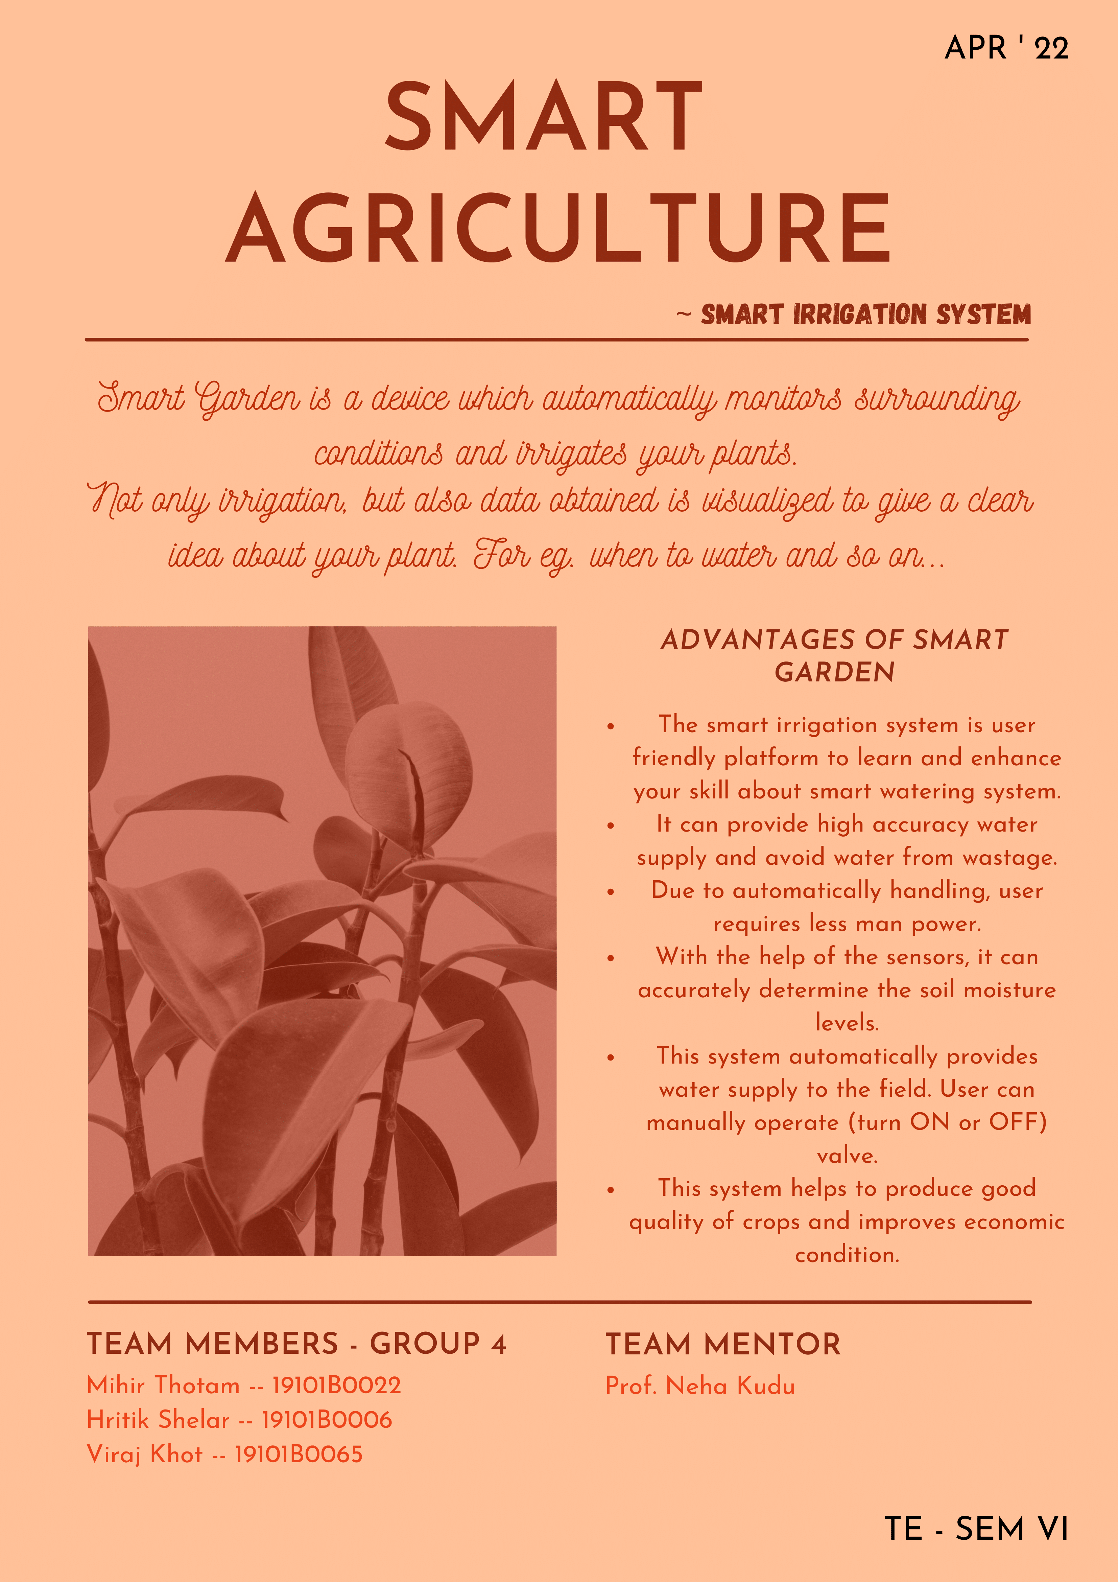

**Github Link:**

[**https://github.com/NiGhtKinG17/Smart-Irrigation-System.git**](https://github.com/NiGhtKinG17/Smart-Irrigation-System.git)